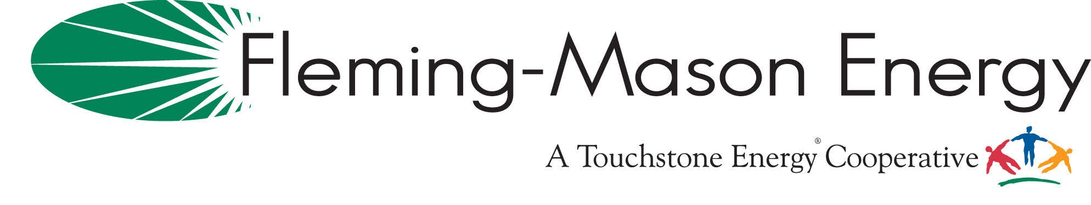
FLEMING-MASON ENERGY & COBANK’S SHARING SUCCESS MATCHING GRANT PROGRAM

APPLICATION FORM:

Please return to Lori Ulrich at FME: 1449 Elizaville Rd, Flemingsburg KY 41041. E-Mail:
lulrich@fme.coop. Applications must be received by 11:59pm on Monday, June 1st, 2026. Contact Lori Ulrich at 800-464-3144 or at lulrich@fme.coop with any questions.
Nonprofit Organization Name
Address ________________________________________________________City ___________________
State __________________ Zip __________ TIN (Taxpayer Identification Number ___________________
Contact Name __________________________________ Title ___________________________________
Contact Phone __________________________________ Email __________________________________
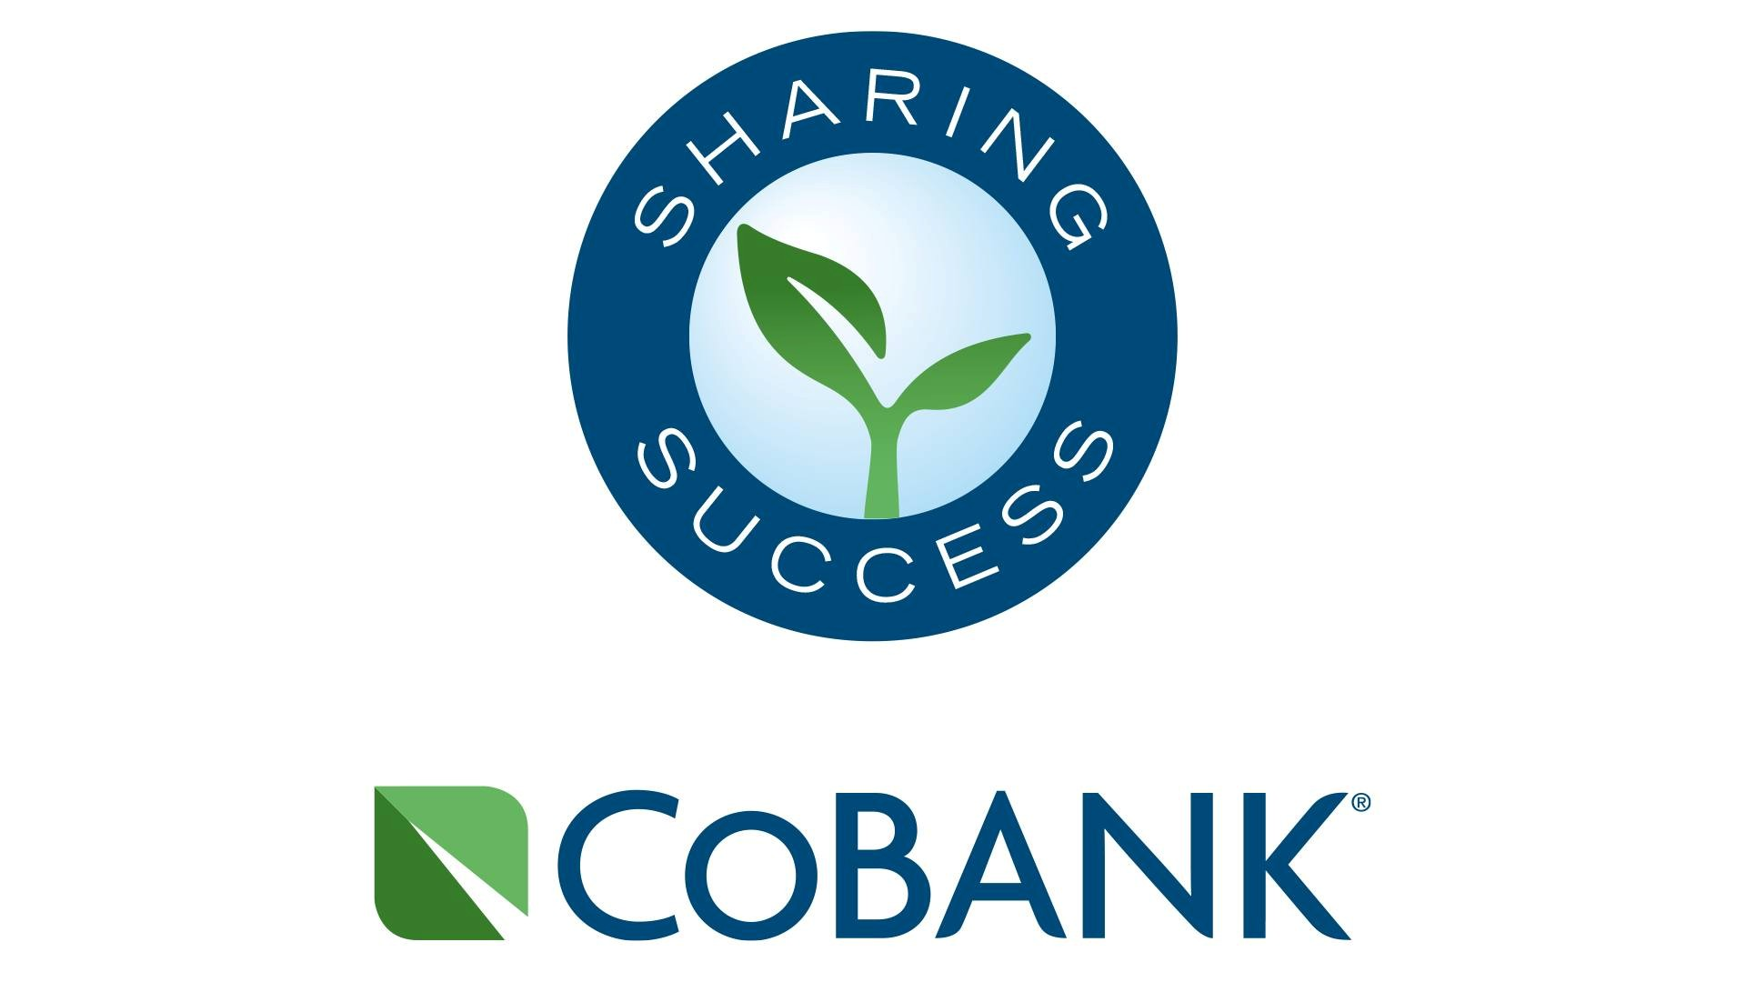
Intended Use of Grant: Please provide a brief description of the organization, program, and intended use of the contribution. You may attach documents if necessary:

______________________________________________________________________________________
Proof of the nonprofit organization’s 501(c)(3) status must be provided with this application. Select organizations that are not designated a 501(c)(3) are also eligible. These organizations include schools and government organizations, such as counties or municipalities and their agencies or departments, as long as the donation serves a public purpose and is consistent with the purpose and guidelines of the Sharing Success program. If the recipient is not a 501(c)(3), please submit the organization’s TIN (taxpayer identification number). Matching funds are contingent upon the availability of funds from CoBank; FME will contribute funds regardless.
Applicant’s Signature

